GAP ANALYSIS EXERCISE
Demand–Supply of Protein Powder for Gym-Going Youth in Rural Areas

1. PURPOSE OF THE GAP ANALYSIS
To identify the mismatch between demand and supply of protein powder in rural gym ecosystems and propose strategic interventions to bridge the gap in terms of availability, affordability, awareness, and trust.

2. TARGET SEGMENT
- Population: Gym-going youth (18–35 years)
- Geography: Rural and semi-rural areas
- Income Level: Low to middle income
- Fitness Objective: Muscle gain, stamina, fat loss

3. CURRENT STATE vs DESIRED STATE (GAP ANALYSIS TABLE)
Dimension | Current State (Supply Side) | Desired State (Demand Side) | Identified Gap
Availability | Limited brands, irregular stock | Consistent local availability | Distribution gap
Affordability | High-priced urban brands | Low-cost, value packs | Price gap
Awareness | Low nutrition literacy | Clear understanding of protein needs | Knowledge gap
Trust | Fear of fake/adulterated products | Verified, safe products | Credibility gap
Accessibility | Dependence on nearby towns | Easy village-level access | Access gap
Customization | Generic formulations | Need-based (beginner, vegetarian) | Product gap

4. ROOT CAUSE ANALYSIS (FOR GAPS)
Demand-Side Issues
- Limited nutritional awareness
- Myths regarding protein supplements
- Price sensitivity
- Lack of professional guidance
Supply-Side Issues
- Urban-centric distribution model
- High logistics and retail margins
- No rural-focused product variants
- Weak last-mile delivery

5. LUCIDCHART FLOW DIAGRAM (TEXTUAL BLUEPRINT)
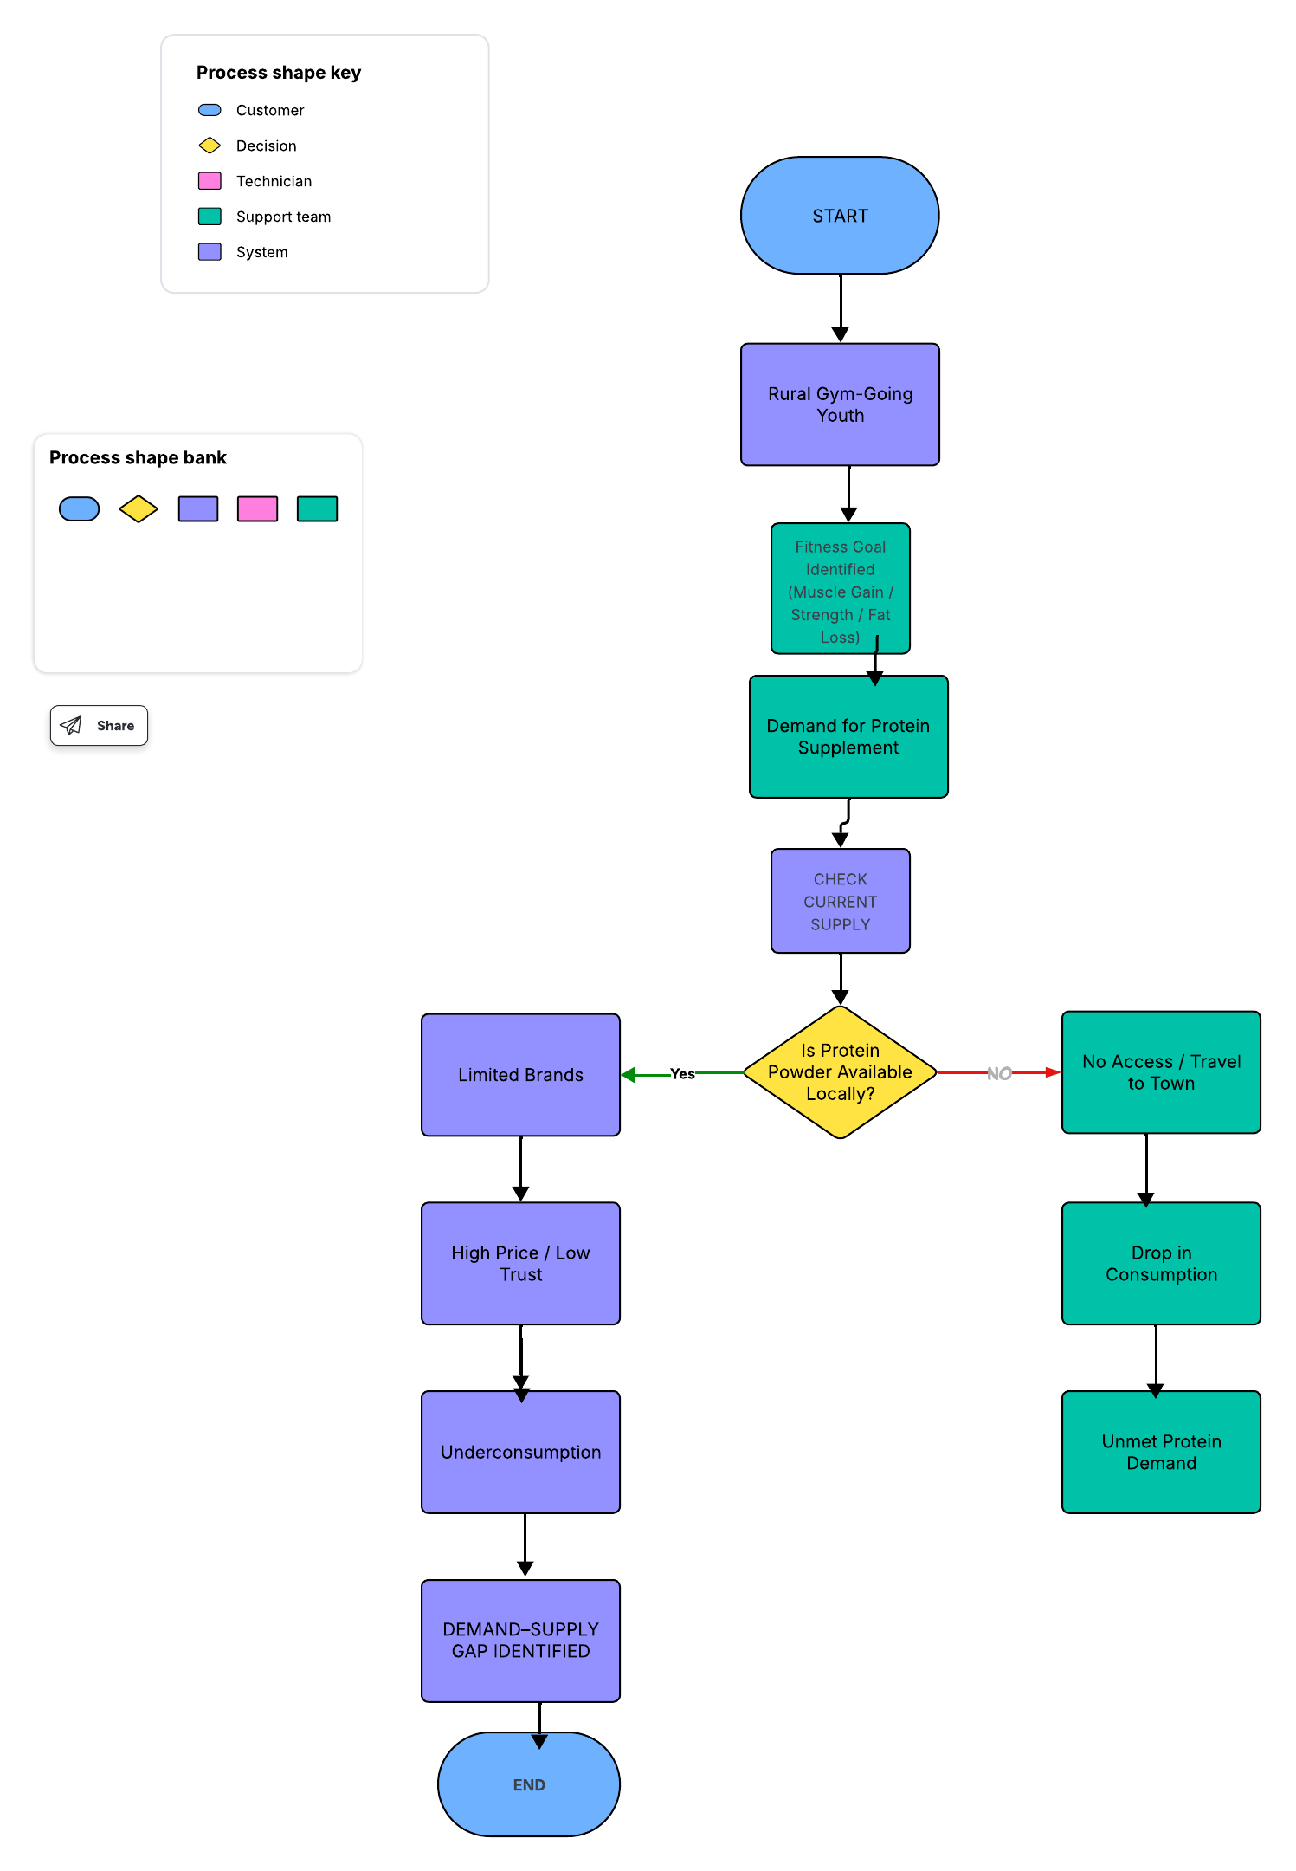
6. GAP CLASSIFICATION (LUCIDCHART SWIMLANE IDEA)
Swimlane 1: Demand Side
- Need for affordable protein
- Need for safe & genuine products
- Need for guidance
Swimlane 2: Supply Side
- Limited distribution
- High pricing
- Urban-centric marketing

